Manual – Time Series v 1.1 Add-in
Jakub Rybacki, jakub.rybacki@gmail.com

Warsaw, 2014

Table of Contents
Introduction 3
Installation 3
Keyboard Shortcuts 3
Requirements 3
Hodrick-Prescott Filter 4
Comparison with Statistical Packages (Eviews) 4
Deterministic Seasonal Adjustment 5
Trend Extralpolation 6
Corelogram 7
Comparison with Eviews 7

Introduction
The aim of this document is to present Time Series Add-in, which extends basic functionality of Excel by a following analytical tools:
- Hodrick-Prescott Filter
- Trend Extrapolation by Holt, Holt-Winters Model
- Deterministic Seasonal Adjustment (seasonal dummies regression)
- Correlogram

Installation
Installation of add-in would create additional menu on Add-ins tab at the ribbon:
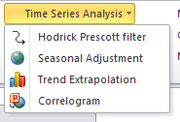
Also following keyboard combination would be overridden:

Keyboard Shortcuts

Shortcut | Action
CTRL + SHIFT + F7 | Hodrick-Prescott Filter
ALT + SHIFT + F7 | Trend Extrapolation
CTRL + ALT + F7 | Deterministic Seasonal Adjustment

Requirements
Time Series Add-in requires Solver installed. Official instruction how to install this add-in is available here. You may also find helpful following video.
Please note also that every tool implemented in this add-in assumes that data is stored in rows (worksheet is column-oriented).

Hodrick-Prescott Filter
Selection of Hodrick Prescott filter option, or pressing CTRL + SHIFT + F7, triggers display of following interface:
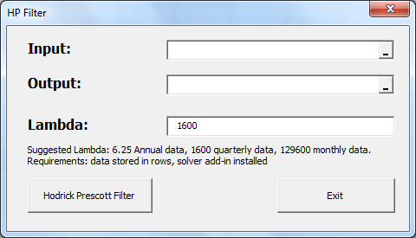
Input field contains data, which would be transformed by Hodrick-Prescott Filter - you may select few rows in one go. Please remind that good estimate of trend by this technique has following requirements: 1) No missing data occurs. 2) All outliers (Additive Outliers, Transitory Changes) are corrected (important in case of monthly data). 3) Few observation at the head and bottom of the series are excluded (it is generally accepted practice to add e.g. consensus forecast to hard data in order to improve estimate of value for current period).
Output field contains reference to place, where we want to put the data. Please remind that Input data and output data must belong to the same worksheet. Also for your convenience it is sufficient, when you select only one cell, where you want to put output series.
Lambda field contains information about lambda parameter responsible for series smoothness. By default its values is set to 1600, as it was recommended by Hodrick and Prescott for quarterly data.

Comparison with Statistical Packages (Eviews)
Time Series Add-in implements original Hodrick Prescott formula derived from original paper. Outcomes of my macro may somehow differs from professional statistical packages due to: 1) different optimization technique. 2) There were several adjustments to this technique proposed by another authors. Professional, commercial statistical packages may implements such extensions.

Deterministic Seasonal Adjustment
Selection of Seasonal adjustment option or pressing CTRL + ALT + F7 would trigger following interface:
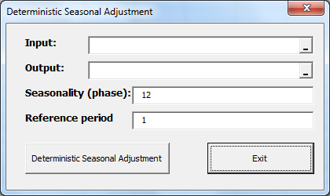
This programs allows for removal of seasonal components, based on linear regression with dummies representing constant (average) seasonal factor occurring in selected period. Field reference period contains information, which period is used as a base one (dummies for this period are excluded from equation). Please note that macro would not due adjustment of generated seasonal adjustment series to the average, thus the period, which is as close as it possible to average shall be selected.
Seasonality (phase) field contains information, how many periods constitute one phase. By default add-in in selected for monthly data (12 periods in one cycle).
Input field contains reference to raw data, which shall be adjusted. Similarly like in case of Hodrick Prescott selection of few series in one go is available. As in case of HP filter Output field contains single cell, indicating where outcomes would be printed.
Example of macro application on polish prices of vegetables (MoM dynamics of CPI component) is presented below (with base month April):
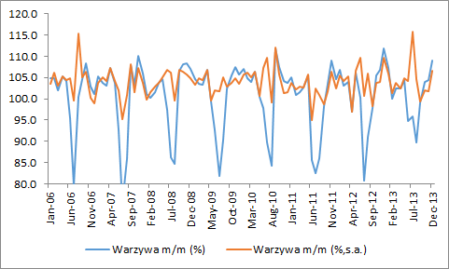

Trend Extralpolation
Selection of Trend Extrapolation option, or pressing ALT + SHIFT + F7 would trigger following interface:
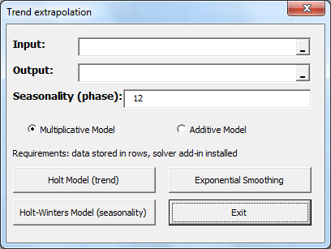
Program allows for extrapolation of linear trend based on Holt Model or Exponential Smoothing, as well as extension of series with presence of seasonal factors (Holt-Winters Model). In case of Holt-Winters model it is necessary to indicate how many periods constitute one cycle (seasonality (phase) field) – by default 12 months (constituting one year) is selected.
Each model is programmed in two variants – multiplicative (requiring every observation to be positive), or additive. Differences before this two approaches are described here.
Contrary to the previous functions (HP filter and Seasonal Adjustment) Output field requires indicating exact number of periods, where trend would be extrapolated. Also in case of Input field only one series would be calculated.

Corelogram
Selection of Correlogram option would trigger following interface:
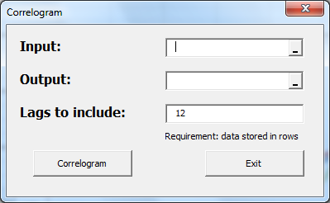
Application works similarly like in case of seasonal adjustment program. By default 12 lags is selected.

Comparison with Eviews
Correlogram’s calculation is based on Matlab’s documentation, results are similar to Eviews:

Final chart presented by this macro are presented below:

