Manual – Technical Analysis Add-in
Jakub Rybacki, jakub.rybacki@gmail.com

Warsaw, 2014

Table of Contents
Introduction 3
Installation 3
Keyboard Shortcuts 3
Technical Analysis Indicators 4
Fibonacci’s levels 5
Appendix 1 – Technical Analysis Indicators– Required Data 6

Introduction
The aim of this document is to present Technical Analysis Add-in functionality. The main functionality include:
- Drawing Fibonacci’s levels
- Implementation of every major important technical analysis indicator

Installation
Installation of Technical Analysis Add-in would create following menu in Add-ins tab at the ribbon:
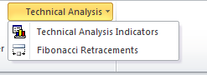
Additionally following keyboard shortcuts would be overridden:

Keyboard Shortcuts

Shortcut | Action
CTRL + SHIFT + F11 | Technical Analysis Indicators
ALT + SHIFT + F11 | Fibonacci’s levels

Technical Analysis Indicators
Selection of Technical Analysis Indicators options, or pressing CTRL + SHIFT + F11 would trigger following menu:
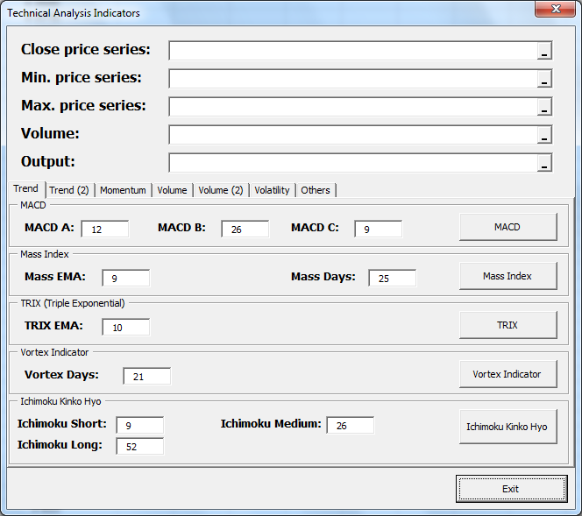
Each indicator uses data from fields on the top of form (highlighted by orange rectangle), also every indicator has its default (most common) settings set. All in all, final user would receive more than 25 different technical analysis techniques: vast majority would print detailed output, which step-by-step guides how formulas were created. Also plethora of charts was automatized to increase your comfort.
Please note that each technique may have different input required: whereas some of them are basing only on close price, others may require also minimum and maximum price or volume (or both). Full specification of required data is presented in Appendix 1.

Warning!
Please, have in mind that output of indicators may require few columns. Thus always set output cell far from your data (unfortunately output has to be printed in the same worksheet with data).

Fibonacci’s levels
Selection of Fibonacci Retracements option, or pressing ALT + SHIFT + F11 would trigger following menu:
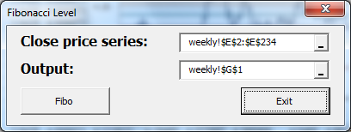
Intuitively we put series containing closing price of our commodity/index etc. to the field called Close price series, and select a space for output (single cell indicating beginning of output space). There is one rule, which shall be remained – please put the output place far from your data, program produces more than 10 columns of output. Also do not be afraid of initial series – program would rewrite it. Final chart created by programs is presented below (EUR/PLN since 2010/01/01 to the end of 2014/06/01)

Appendix 1 – Technical Analysis Indicators– Required Data
Trend Indicators – panel no. 1
Indicator | Close Price | Minimum Price | Maximum Price | Volume
MACD | X
Mass Index | X | X | X
TRIX | X
Vortex | X | X | X
Ichimoku Kinko Hyo | X | X | X
Trend Indicators – panel no. 2
Indicator | Close Price | Minimum Price | Maximum Price | Volume
ADX | X | X | X
KST | X
Momentum Indicators
Indicator | Close Price | Minimum Price | Maximum Price | Volume
Relative Strength Index | X
True Strength Index | X
Williams %R | X | X | X
Volume Indicators – panel no. 1
Indicator | Close Price | Minimum Price | Maximum Price | Volume
Accumulation / Distribution Index | X | X | X | X
On Balance Volume | X |  |  | X
Money Flow Index | X | X | X | X
Volume Price Trend | X |  |  | X
Force Index | X |  |  | X
Volume Indicators – panel no. 1
Indicator | Close Price | Minimum Price | Maximum Price | Volume
Ease of Movement Index | X | X | X | X
Negative Volume Index | X |  |  | X

Volatility Indicators
Indicator | Close Price | Minimum Price | Maximum Price | Volume
Bollinger Bands | X
Donchian Channel | X | X | X
Average True Range | X | X | X
Others (sometimes a bit exotic) indicators
Indicator | Close Price | Minimum Price | Maximum Price | Volume
Pivot Point | X | X | X
Keltner Channel | X | X | X
Coppock Curve | X
Commodity Channel Index (CCI) | X | X | X
Ulcer Index | X
Ultimate Oscillator | X | X | X

