Manual – Macro Charts v 1.1 Add-in

Jakub Rybacki, jakub.rybacki@gmail.com

Warsaw, 2014

Table of Contents

Introduction 3

Instalation 3

Keyboard Shortcuts 3

Seasonal Plot 4

Enhancing the Chart 5

Scatter Plot – Cross Section Data 6

Enhancing the Chart 7

Known Issues 8

Scatter Plot – Time Series 8

# Introduction

The aim of this document is to present functionality of Macro Charts Add-in. This application contains three extensions of basic Excel charts:

* Seasonal plot – Column chart grouping observations, which belongs to the same period in the cycle. This chart gives an invaluable support in case of analyzing strongly seasonal phenomenon like: dynamics of construction/industrial production, vegetables/fruits’ prices etc.
* Labelled Scatter Plot of Cross-Section Data – this module extends functionality of basic Scatter Plot, allowing for labeling names of observations
* Scatter plot of Time Series Data – this module would create a Scatter Plot presenting variable behavior during business cycle

# Instalation

Installation of Macro Charts Add-in would create following menu in the Add-ins tab at the ribbon:

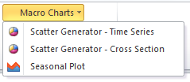

Also functionality of some keyboard combinations would be overridden. Details below:

## Keyboard Shortcuts

|  |  |
| --- | --- |
| Shortcut | Action |
| CTRL + SHIFT + F4 | Seasonal Plot |
| ALT + SHIFT + F4 | Labelled Scatter Plot of Cross-Section Data |
| CTRL + ALT + F4 | Scatter plot of Time Series Data |

# Seasonal Plot

Selection of ***Seasonal plot*** option, or pressing **CTRL + SHIFT + F4** would trigger following form:

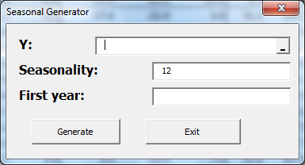

In the first field (**Y**) reference to a data range shall be selected, ***seasonality*** in line with basic intuition states how many periods constitute one cycle (by default value is set for monthly data – 12 months constitute one year). Finally ***first year*** contains numeric value of first year in your data (e.g. 2005).

Add in produces line chart, where all observation belonging to the same period are grouped together. Output of such exercise is visible below:

Despite default view may convey important information, there is a possibility that this chart would be unreadable. In the next chapter I would suggest few ways of enhancing such chart.

## Enhancing the Chart

As you can see in previous chapter seasonal plot produced by Macro Charts add-in is in some case too unorganized to be functional. This is not a big deal, there are few steps, which allows you create much better outlook. They are as follows:

* Delete grid line –just by pressing **delete** at the grid
* Change chart type to column–right click on the area of the chart, and select *‘change chart type*’. Then select the first column-chart (pictures unfortunately with polish interface):

|  |  |
| --- | --- |
|  |  |

* Place the legend at the bottom of the chart - right click on the legend area and select *‘format legend’*. First tab, which would appear is used to change the position (again polish interface on pictures):

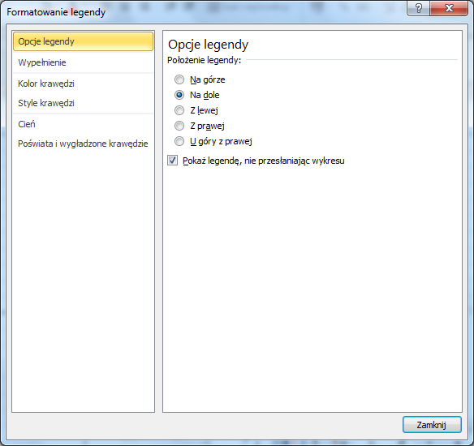

Final effect of our work looks like this:

# Scatter Plot – Cross Section Data

Selection of ***Scatter Generator – cross section*** option***,*** or pressing **ALT + SHIFT + F4** would trigger following form:

|  |  |
| --- | --- |
|  |  |

First panel allows you to create a chart from scratch, fields **X** and **Y** are the coordinates of two scales, **Labels** shall indicate values, which would be an identification of the element (country code, share ticker etc.).

Second panel allows you to change graph layout (changing X axis with Y axis and vice versa), or rotating the scale (from positive to negative or vice versa) for both scales.

Exemplary scatter plot is presented below:

Like in case of seasonal plot, there is also a few tricks helping enhance the final chart design.

## Enhancing the Chart

To improve quality of created chart, basic Excel’s formatting options are sufficient – as the first step we would change the scale of produced chart. To do so, just right-click on the scale and select *format axis*. In the following menu select automatic shape of two axis or change it manually; Results are provided below:

|  |  |
| --- | --- |
|  |  |

In the next step go to the Chart Tools -> *Layout*-> *Axis title.* Then add titles to both axis, you may also add trend line and R-squared coefficient if you wish.

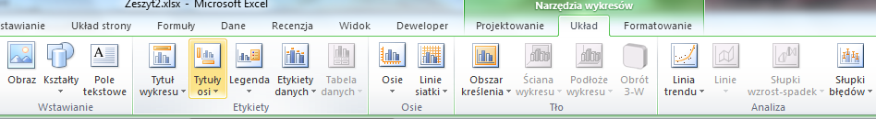

Final chart (with polish language) is presented below:

## Known Issues

In older versions of Excel there is a possibility that first element would not be correctly labeled (label remains empty). Such malfunction can be corrected manually.

# Scatter Plot – Time Series

Selection of ***Scatter Generator – time series*** option***,*** or pressing **CTRL** **+ ALT + would trigger following form**:

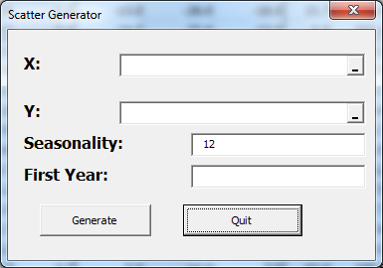

As in case of cross-sectional scatter plot similarly here **X** and **Y** shall contain two equally-lengthen series, which we wish to pair **Seasonality** indicates how many periods constitute one cycle (by default 12 months constituting one year are selected). In case of field **first year** numeric value shall be presented (similarly like in case of seasonal plot).

Exemplary chart is presented below:

Please not that every year presented in the chart has its own color, also dates are attached at the first period of cycle (in such case January). This chart may be enhanced similarly like cross-sectional plot.