Manual – Linear Regression v 1.1 Add-in
Jakub Rybacki, jakub.rybacki@gmail.com

Warsaw, 2014
Table of contents
Introduction 3
Installation 3
Keyborard Shortcuts 3
Requirements 3
Diagnostics 4
Implying Exogenous Variable 5
Outliers Detection 6
Filtering Outliers 7
VIF Statistics 8

Introduction
The aim of this document is to present functionality of Linear_Regression Add-in, which extends function of Analysis Tool Pack Linear Regression, containing simple and user friendly diagnostic tools.
- Diagnostic test (RESET test, Breusch-Pagan test, Durbin-Watson test, Jarque-Bera test).
- Outliers Detection tools (based on Cook’s distance and leverage based statistics)
- Interface for Implying exogenous variable, knowing value of endogenous parameter (based on a goal seek function)
- Collinearity detection based on VIF statistics.

Installation
Installation of Linear_Regression Add-in would create following menu in the Add-ins tab at the ribbon:
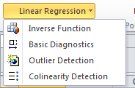
Also functionality of some keyboard combinations would be overridden. Details below:

Keyborard Shortcuts

Shortcut | Action
CTRL + SHIFT + F8 | OLS Diagnostics
ALT + SHIFT + F8 | Exogenous variable implication
CTRL + ALT + F8 | Outliers Detection

Requirements
Time Series Add-in requires Solver installed. Official instruction how to install this add-in is available here. You may also find helpful following video.
Please note also that every tool implemented in this add-in assumes that data is stored in rows (worksheet is column-oriented).

Diagnostics
Selection of Basic Diagnostics option, or pressing CTRL + SHIFT + F8 would trigger following interface:
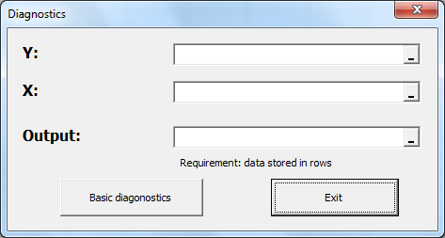
Description of input field is quite intuitive – in y field we select full scope of endogenous variable, x field scope of exogenous variables, in Output field single cell referring to a place where output should be printed (output must be printed in the same worksheet were data is stored):
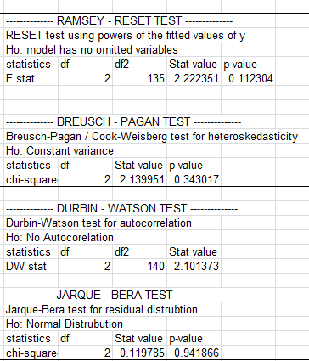
All stats were tested and are in line with Eviews results expects Jarque-Beta test. In case of JB test skewness and kurtosis yield similar results, however test formula is different. Linear Regression uses most common formula presented below:
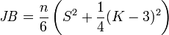

Implying Exogenous Variable
Selection of Inverse Function option, or pressing ALT + SHIFT + F8 would trigger following interface:
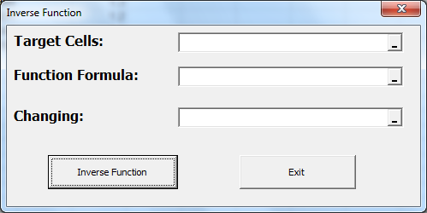
In field Target Cells scope of target values for endogenous variables shall be selected (this cells has to be pasted with paste values option). Field Function formula would contain similar scope by size, however in case of this cells formulas must be stored. Finally in Changing field scope of exogenous variables, which would be recalculated. All can be summarized by picture below:
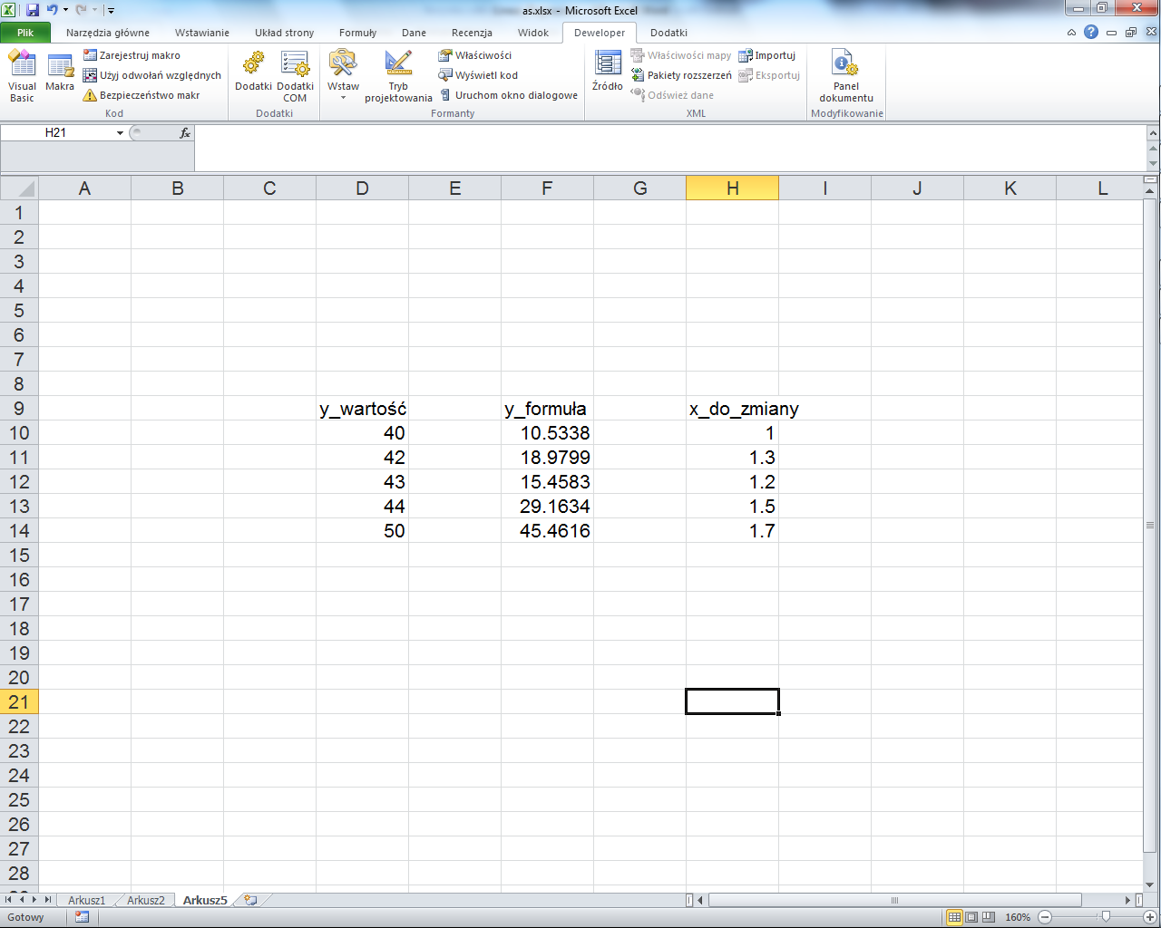
Formula (in case of 10th row): =1.3*POWER(H10;3)*EXP(H10)+5*H10+2
(field function formula)
X – endogenous variables selected in field changing
Targeted values of Y pasted as values
All X-es would be recalculated in such manner that column with formulas would have as similar values as it possible comparing to targeted Y-es. Macro assumes that whole data is stored in a single worksheet.

Outliers Detection
Selection of Outlier Detection option, or pressing CTRL + ALT + F8 would trigger following interface:
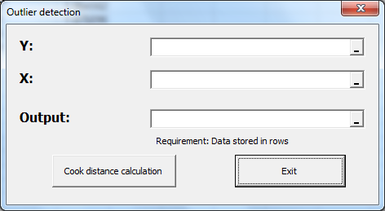
Input selection is similar like in case of Diagnostics – y contains endogenous variables, x exogenous variables, Output a single cell indicating, where output shall be printed (all should be stored in one worksheet). Output of macro based on randomly generated variables are presented below:
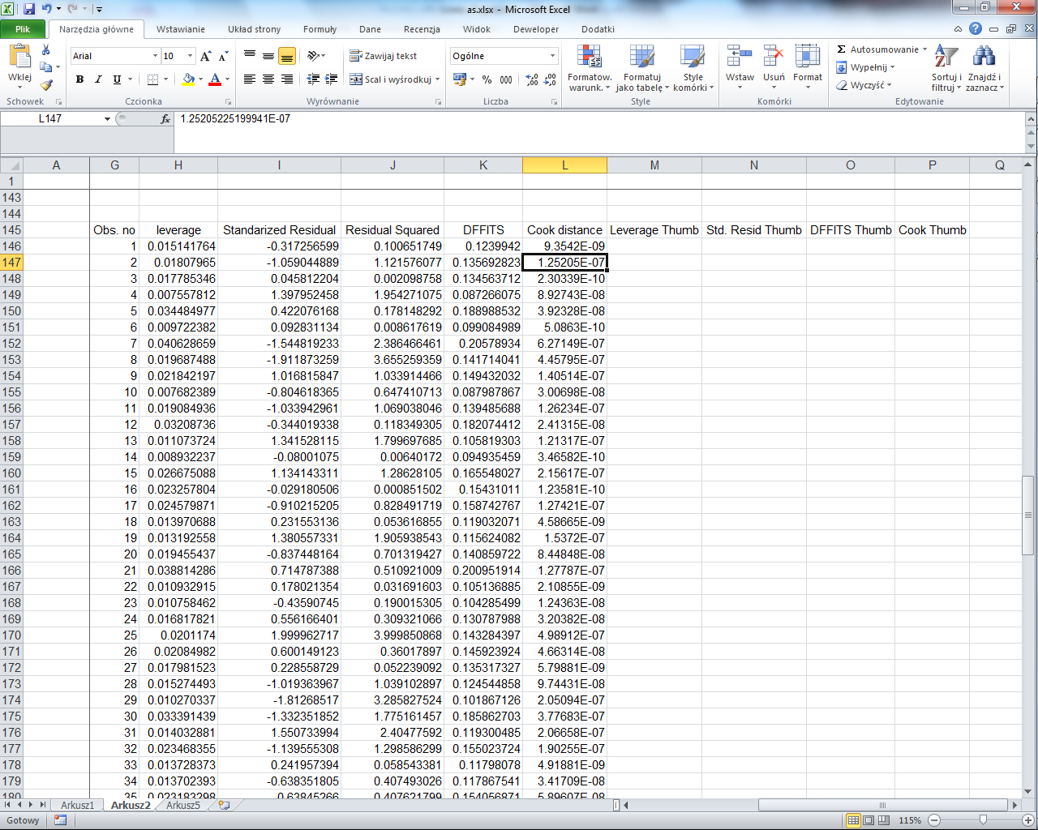
First 5 columns contains statistics explaining overall impact of observation on beta parameter. This are following: leverage statistic, standardized residual, its square, DFFITS statistics and Cook distance. Last five columns containing popular thumb rules allowing for quick outlier filtering.

Filtering Outliers
Before filtering outliers it is recommended to copy basic worksheet in order to prevent data loss (to do such operation right-click on a worksheet name and select move/copy worksheet). In the next step copy output of the outliers detection program adjacent to your x-es. Finally select option Data-> Filter and select heuristics based on which you would delete your outliers.
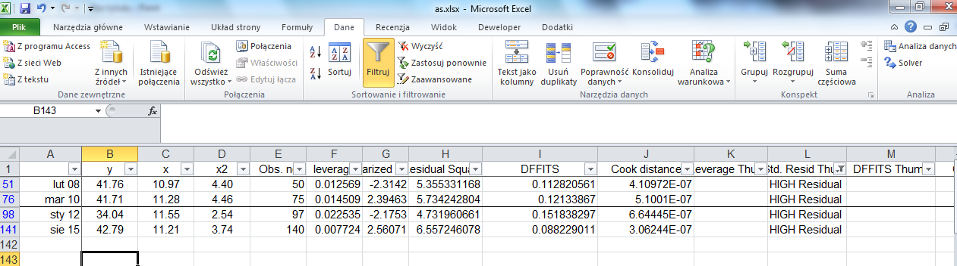
At the end delete rows with outliers.

VIF Statistics
Selection of Colinearity Detection option would trigger following interface:
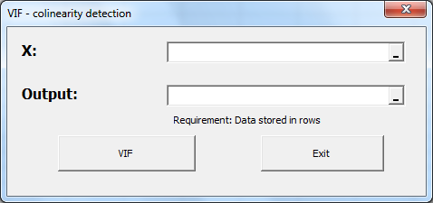
Field selection is quite intuitive –x field contains exogenous variables scope, Output single cell when output shall be printed (in the same worksheet). Let’s check output for randomly selected variables where x3=x2-x1:
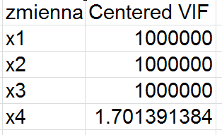
Eliminating 3rd variable from output would yield acceptable results (note that variable formerly labeled as x4 became x3 due to elimination third variable from x-es):
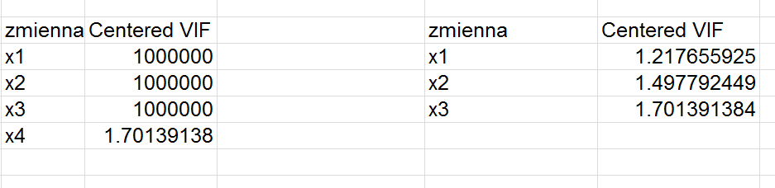

Results were tested and were identical as Eviews outcomes.

