Manual – Chart Fitter Add-in
Jakub Rybacki, jakub.rybacki@gmail.com

Warsaw, 2014

Table of Contents
Introduction 3
Installation 3
Keyborad Shortcuts 3
Chart Modification 4
Adding/Deleting Observations 4
Lagging/Leading 4
Known Issues 5
Symmetrical Changes of Scale 5
Point of Information – No.1 5
Point of Information – No.2 5
Asymmetrical Changes of Scale 6
Finishing Work with Addin 6
Auto Scaler 7
Constraints 7

Introduction
This manual presents Chart-Fitter Add-in functionality. The aim of this application is to improve modification of charted data by:
- Adding/deleting observation at the beginning and at the end of the series
- Modifying both scales (primary/secondary) of a chart
- Lagging/Leading series
Also inside the add-in automatic fitting algorithm (minimizing absolute sum of pixels between two series based on genetic algorithm called differential evolution) is available.

Installation
Installation of Chart-Fitter add-in creates following menu on add-in tab at the ribbon:
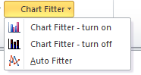
Also add in overrides following keyboard shortcuts

Keyborad Shortcuts

Shortcut | Activity
CTRL + SHIFT + F5 | Chart Fitter Activation
ALT + SHIFT + F5 | Chart Fitter Deactivation
CTRL + ALT + F5 | Automatic Scaler
Activation/Deactivation would override few basic excel keyboard combinations. Their functionality would be described in the next Chapter.

Chart Modification

Adding/Deleting Observations
Basic functionality of Chart Fitter includes adding/deleting observation at the beginning and at the end of the series. Data can be row-oriented or column-oriented. To modify number of observation use:
Shortcut |  | Activity
CTRL + ENTER (NUM) | Adding observation at the end of the series
ALT + ENTER (NUM) | Deleting observation at the end of the series
CTRL + SHIFT + ENTER (NUM) | Deleting observation at the beginning of the series
ALT + SHIFT + ENTER (NUM) | Adding observation at the beginning of the series
WARNING!: Mentioned ENTER key belongs to numerical keyboard as it is presented below.
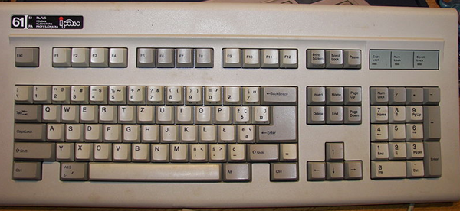

Lagging/Leading
Macro also allowing for implementation of lagging/leading relationships up to 3 series. Such modifications are available using CTRL/ALT combined with numerical keyboard keys:
Shortcut | Activity
CTRL + NUM1 | Increase lag for 1st series
CTRL + NUM2 | Increase lag for 2nd series
CTRL + NUM3 | Increase lag for 3rd series
ALT + NUM1 | Decrease lag for 1st series
ALT + NUM2 | Decrease lag for 2nd series
ALT + NUM3 | Decrease lag for 3rd series
Increasing/Decreasing lag by Chart Fitter also modify legend entry, giving exact information about lag no.

Known Issues
In Windows, combination alt + number has additional application – it allows to write a sign by using ASCII code. In case whether lag decreasing operator (alt + number) gave no effect, it is probable that we are typing content into formula editor by an ASCII code. In such case changes can be reverted just by typing escape.

Symmetrical Changes of Scale
The most powerful functionality offered by chart fitter is to adjust charting scales just to better capture the nature of relationship between series.. To modify primary scale use:
Shortcut | Activity
CTRL + SHIFT + UP | Shifts series upward (maximum and minimum of the scale are increased by the same amount)
CTRL + SHIFT + DOWN | Shifts series downward (maximum and minimum of the scale are decreased by the same amount)
CTRL + SHIFT + LEFT | Flatten the scales
CTRL + SHIFT + RIGHT | Widen the scales
Analogical functionality is available for secondary scale:
Shortcut | Activity
ALT + SHIFT + UP | Shifts series upward (maximum and minimum of the scale are increased by the same amount)
ALT + SHIFT + DOWN | Shifts series downward (maximum and minimum of the scale are decreased by the same amount)
ALT + SHIFT + LEFT | Flatten the scales
ALT + SHIFT + RIGHT | Widen the scales

Point of Information – No.1
Adding amount to the scales as well as widening/flattening the scale occurs based on percentage value of current minimum/maximum. Such algorithm unfortunately have some limitations – in case of positive numbers it would be impossible to go beyond 1 (in case of negative number -1). Thus whilst coming close to 1, macro is shifting chart using a threshold.
In case of having data, which is close to 1 (e.g. discount factors) it is recommended, to multiply such series by 100.

Point of Information – No.2
All of scale modification can be easily reverted in chart’s format menu. Right-clicking on selected axis and selecting-> ‘Format axis’ option, display a menu, where scale can be changed. Setting scale limitations to auto yields chart outlook, available before Chart-Fitter operations

Asymmetrical Changes of Scale
Another useful possibility of chart is to asymmetrically shifts one element of the scale (minimum/maximum). In case of primary axis, following combinations can be used:
Shortcut | Activity
CTRL + UP | Shifts Maximum upwards
CTRL + DOWN | Shifts Maximum downwards
CTRL + LEFT | Shifts Minimum upwards
CTRL + RIGHT | Shifts Minimum downwards
Analogical functionality is available for secondary axis:
Shortcut | Activity
ALT + UP | Shifts Maximum upwards
ALT + DOWN | Shifts Maximum downwards
ALT + LEFT | Shifts Minimum upwards
ALT + RIGHT | Shifts Minimum downwards

Finishing Work with Addin
After finishing work with Chart Fitter press the combination ALT + SHIFT + F5 to deactivate overridden Excel functionality. In case of attempt to use Excel functionality, whilst Chart Fitter is active, you will receive error message, telling that no chart was selected (unfortunately screen came from polish version, English version is fully translated)
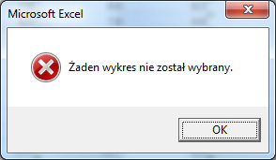
Error is harmless for stored data.

Auto Scaler
Last but not least functionality of Chart Fitter is so called auto scaler – an evolution algorithm for automation of scaling (unfortunately it is less efficient than shifting scales manually). To open main menu of auto scaler press CTRL + ALT + F5. Following menu would be displayed (unfortunately screen comes from polish version, still in case of English description it would be quite intuitive to use it):
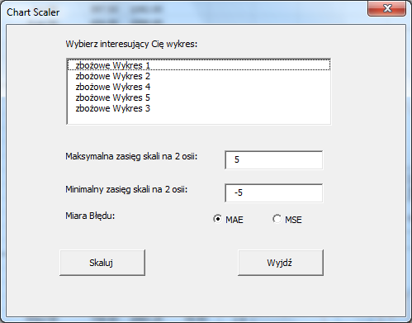
In the big frame at the top of menu, you will select the chart, which you would like to scale. In case if you don’t know what is exact chart name, use Chart-tools -> layout and look at name in the frame at the end of the ribbon, like in a picture presented below (unfortunately I have only a polish interface available in my Excel):
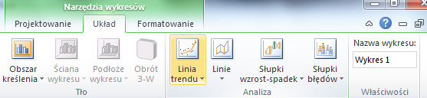

Constraints
Differential Evolution unfortunately has some serious limitations:
- Optimization is time consuming, calculation may last for approximately one minute.
- Algorithm is not immune to over-fitting, some unconstrained attempts to optimize distance between two series may result in totally flat series with giant scales (thus max/min limit was implemented).

